**Interactive Tutorials and Assignments**

**for Biomedical Engineering**

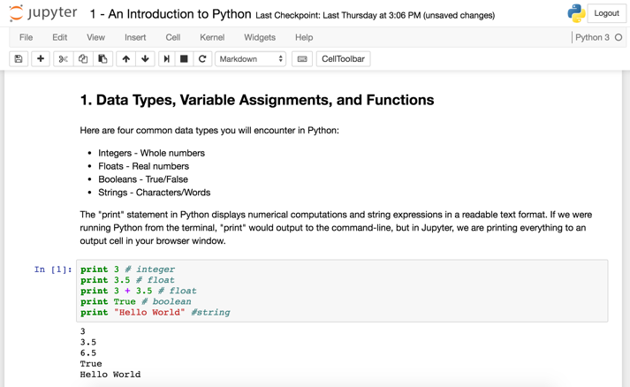

**Faculty**: Eileen Haase

**Fellows**: Richard Chen, Andrew Tsai

**School**: Whiting School of Engineering

**Department**: Biomedical Engineering

**Discipline**: Engineering

**Issue**

Computer programming is becoming pervasive in the field of biomedical engineering more rapidly than we are currently teaching programming to BME undergraduates. The department cursorily introduces MATLAB to BME freshmen in their first semester without sufficient exploration of programming concepts and no connection back to potential biomedical applications of programming. Students with no prior programming experience view programming as daunting or tedious, which prevents them from utilizing the power of programming in all focus areas of BME, not just computational biology. The problem is further manifested when there are continued problems with computer programming literacy in assignments throughout the BME core curriculum, even up to senior year.

**Solution**

A series of interactive Python instructional modules, assignments, and videos were developed, employing Jupyter notebook to provide an easy-to-use environment for beginner programmers to learn Python and programming fundamentals. The modules not only taught programming, but also introduced current direct applications to biomedical engineering.

**Audience**

BME freshmen in 580.111 *BME Modeling and Design*, and other engineering freshmen new to Python or computer programming

**Technologies**

Jupyter Notebook, Python, YouTube